**1)Write a program that checks if a given year is a leap year or not using both if-else and switch-case.**

**Code -** **import java.util.*;**

**public class LeapYear{**

**public static void main(String args[]){**

**Scanner sc = new Scanner(System.in);**

**System.out.println("Enter the Year : ");**

**int year = sc.nextInt();**

**/*if ((year % 4 == 0 && year % 100 != 0) || (year % 400 == 0)) {**

**System.out.println(year+ " is a leap year.");**

**}**

**else {**

**System.out.println(year+" is not a leap year.");**

**}*/**

**int is_leap=0;**

**switch (year % 400 == 0 ? 0 : year % 100 == 0 ? 1 : year % 4 == 0 ? 2 : 3) {**

**case 0:**

**case 2:**

**is_leap = 1;**

**break;**

**default:**

**is_leap = 0;**

**break;**

**}**

**if (is_leap==1) {**

**System.out.println(year+ " is a leap year.");**

**}**

**else{**

**System.out.println(year+" is not a leap year.");**

**}**

**}**

**}**

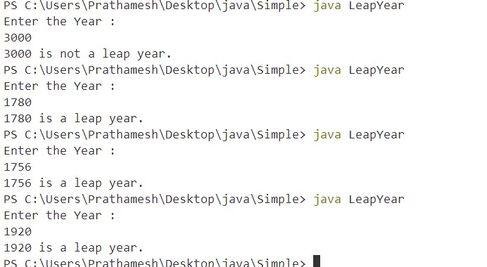

**2)Implement a program that calculates the Body Mass Index (BMI) based on height and weight input using if-else to classify the BMI int categories (underweight, normal weight, overweight,etc).**

**Code -**

import java.util.Scanner;

public class BMIBody{

    public static void main(String[] args) {

    Scanner sc = new Scanner(System.in);

        // Prompt the user for weight and height

        System.out.println("Enter your weight in kilograms:");

        double weight = sc.nextDouble();

        System.out.println("Enter your height in meters:");

        double height = sc.nextDouble();

        // Calculate BMI

        double bmi = weight / (height * height);

        // Classify BMI

        String category;

        if (bmi < 18.5) {

            category = "Underweight";

        } else if (bmi >= 18.5 && bmi < 24.9) {

            category = "Normal weight";

        } else if (bmi >= 25 && bmi < 29.9) {

            category = "Overweight";

        } else {

            category = "Obesity";

        }

        // Display the BMI and the category

        System.out.printf("Your BMI is: %.2f\n", bmi);

        System.out.println("You are classified as: " + category);

        sc.close();

    }

}

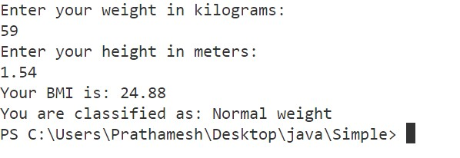

**3)Write a program that checks if a person is eligible to vote based on their age.**

**Code -**

import java.util.Scanner;

class Vote{

    public static void main(String[] args) {

        Scanner sc = new Scanner(System.in);

        int age = sc.nextInt();

        if(age>=18){

            System.out.println(age+" is eligible to vote.");

        }

        else{

            System.out.println(age+" is not eligible to vote.");

        }

        sc.close();

    }

}

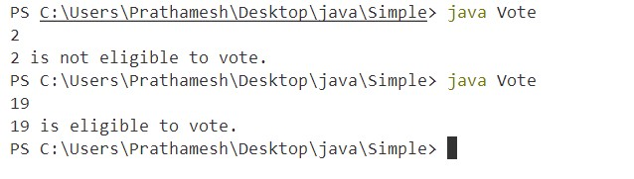**Output -**

4)Write a program that takes a month (1-12) and prints the corresponding season (Winter, Spring, Summer, Autumn) using a switch case

import java.util.Scanner;

public class Season{

    public static void main(String[] args) {

        Scanner sc = new Scanner(System.in);

        System.out.println("Enter your choice");

        int ch = sc.nextInt();

        switch (ch) {

            case 1:

                System.out.println("enter the number of month between 1-12 :");

                int m1 = sc.nextInt();

                if (m1>0 && m1<4) {

                    System.out.println("Winter");

                }

                else {

                    System.out.println("Invalid month for Winter. Winter months are January, February, March.");

                }

                break;

            case 2:

                System.out.println("enter the number of month between 1-12 :");

                int m2 = sc.nextInt();

                if (m2>3 && m2<7) {

                    System.out.println("Spring");

                }

                else {

                    System.out.println("Invalid month for Spring. Spring months are April, May, June.");

                }

                break;

case 3:

                System.out.println("enter the number of month between 1-12 ");

                int m3 = sc.nextInt();

                if (m3>6 && m3<10) {

                    System.out.println("Summer");

                }

                else {

                    System.out.println("Invalid month for Summer. Summer months are July, August , September.");

                }

                break;

            case 4:

                System.out.println("enter the number of month between 1-12 ");

                int m4 = sc.nextInt();

                if (m4>9 && m4<13) {

                    System.out.println("Autumn");

                }

                else {

                    System.out.println("Invalid month for Autumn. Autumn months are October, November, December.");

                }

                break;

            default:

                System.out.println("Invalid Entry");

                break;

        }

        sc.close();

    }

}

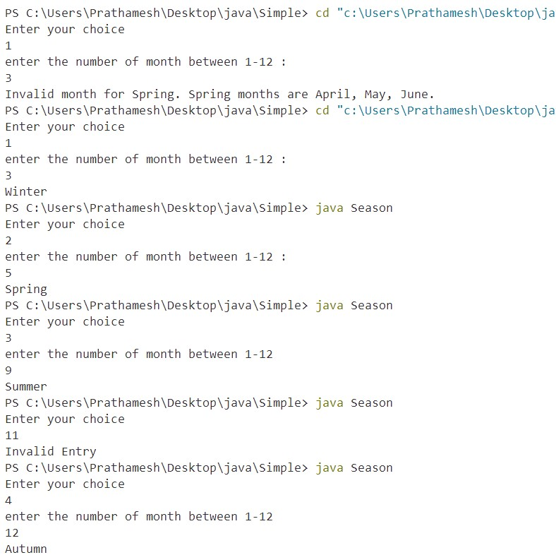 Output -

5)Write a program that allows the user to select a shape (Circle, Square, Rectangle, Triangle) and then calculates the area based on user-provided dimensions using a switch case.

Code –

import java.util.Scanner;

public class Areas{

    public static void main(String args[]){

        Scanner sc = new Scanner(System.in);

        System.out.println("Select the shape to calculate the area");

        System.out.println("1.Circle");

        System.out.println("2.Square");

        System.out.println("3.Rectangle");

        System.out.println("4.Triangle");

        int ch=sc.nextInt();

        double area;

        switch(ch){

            case 1:

                System.out.println("Enter the radius of the circle");

                double radius = sc.nextDouble();

                area = Math.PI * radius * radius;

                System.out.println("The area of circle is : "+area);

                break;

            case 2:

                System.out.println("Enter the length of square");

                double length = sc.nextDouble();

                area = length * length;

                System.out.println("The area of square is : "+area);

                break;

case 3:

                System.out.println("Enter the length of rectangle");

                double len = sc.nextDouble();

                System.out.println("Enter the breadth of rectangle");

                double breadth = sc.nextDouble();

                area = len * breadth;

                System.out.println("The area of rectangle is : "+area);

                break;

            case 4:

                System.out.println("Enter the base of triangle");

                double base = sc.nextDouble();

                System.out.println("Enter the height of triangle");

                double height = sc.nextDouble();

                area = 0.5 * base * height;

                System.out.println("The area of triangle is : "+area);

                break;

            default:

                System.out.println("Invalid Entry");

                break;

        }

    }

}

